

Team Members:

BookShop App

Lap 4

* Mahmoud Mohammed Hammed.

* Mostafa Ashraf Maamoun.

* Mostafa Ali Mohammed Ali.

* Mostafa Morsy Ismail.

Under the Guidance Of:

*Marah Mostafa.

App Activities

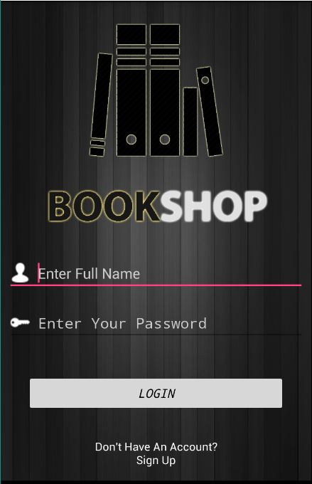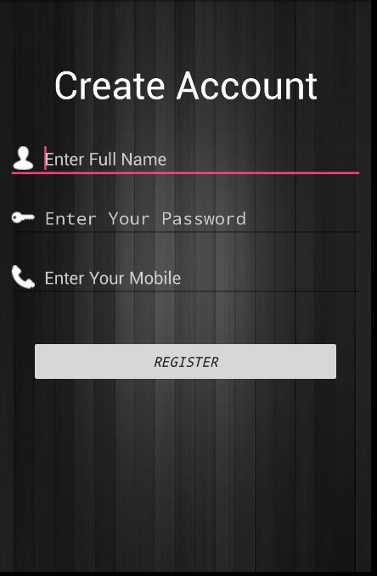

1 -Login Activity.

2- Sign Up Activity.

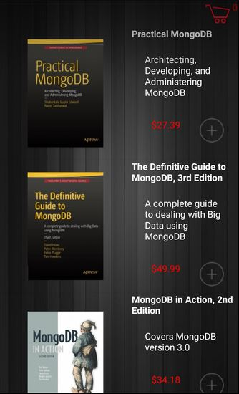 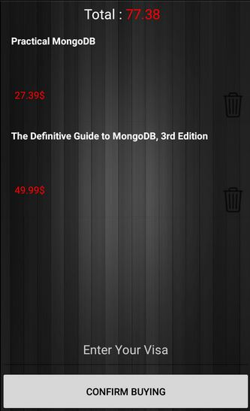

3- BookList Activity.

4- Cart & Confirmation Activity.

Project Classes:

* MainActivity (Login).
* NewAccount.
* DBAdapter (Database Adapter).
* Books.
* BookActivity.
* BookAdapter.
* CartActivity.
* CartAdapter.

1 – Login Activity:

-Login Button

Using the database, it checks for the username the was given in the EditText and the password to take us to the books list activity.



-Login Button Code:

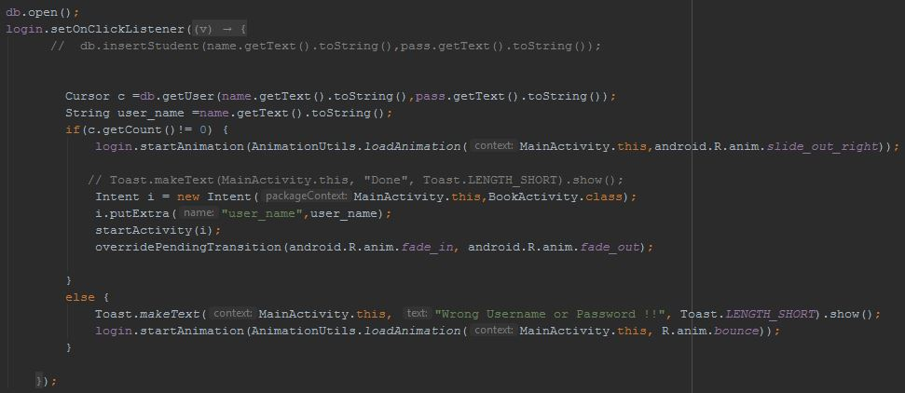

First thing it open the database, then it gets the text from the EditText of name and password, if it were correct it return’s true so it’ll open the next activity passing the username to it, so we can use it later to save data on database.

If we enter wrong username or wrong password there will be a toast appearing in the screen telling us that it’s wrong username or password.

-Sign Up text:

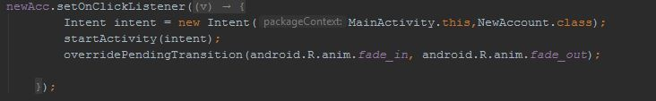

It moves the app to a sign-up screen where the user make a new account and save it to the app’s database.

1 – Sign-Up Activity: 

-Register Button:

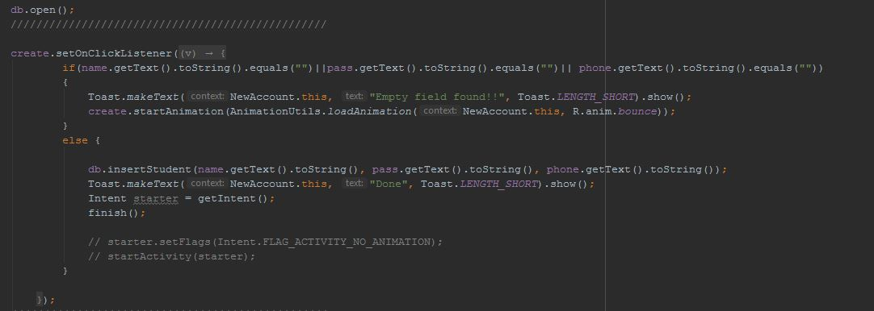

First, we open the database, so we can access it, then when we click on Register button with any of the fields is empty it’ll show a toast with it, else it’ll take the text from the fields and use the insert method from the database’s adapter to insert it into the database, then close this activity and send us back to the Login Activity.

(**) Database Adapter Class Code:

To use the database, we had to create an adapter for it to connect the app with it.

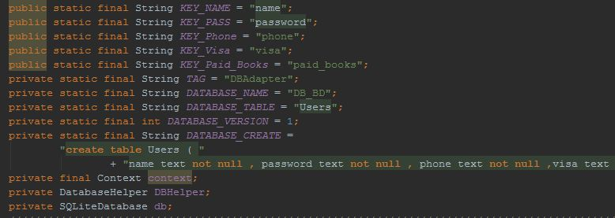

First, we create variables that has the names of the

Database’s columns, name and a create query so we can use it directly.

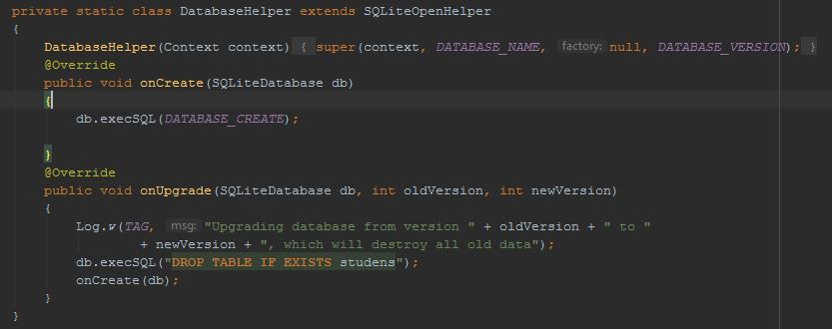

We also have a class the extends the SQLiteOpenHelper that is used to perform a create query and upgrade too.

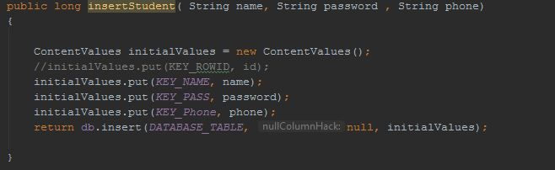

There’s an insert method that takes the parameters from the user and save it to the database’s columns.

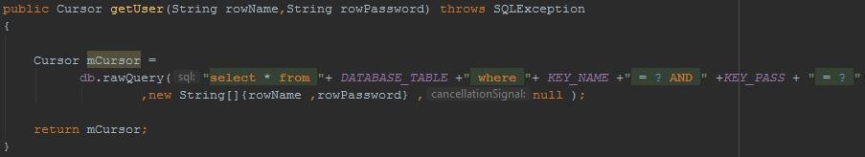

At last we have a select method that we use to check for the username and the password for login.

3 – Book List Activity:



-On this activity first thing onCreate it’ll load (GetData () ;) method the brings the information from the following URL:

” <https://api.itbook.store/1.0/search/mongodb>”

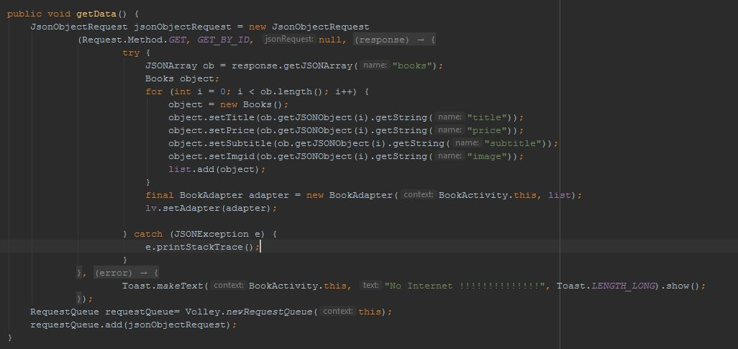

We first make a jsonObject request that requests the server for the information, then we need the “books” Json array from the URL so we create new JsonArray and add the 4 elements (title, price, sub_title, image) we need from the URL, we get it by creating a new object of a class

That we created named as “Books”-see image below for code- it set and get these values, add the elements to the Books object then add it to an arrayList object named as List, then we create an object of the adapter that will attach the arrayList to the ListView on the layout, then create a ListView object and set its adapter to the BookAdapter class’ object we created.

(**) Books Class Code:

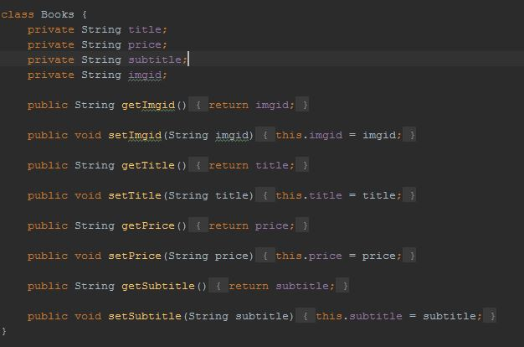

As we said above it set and gets the 4 elements we need from the URL of the JsonObject.

(**) Books Adapter Class Code:

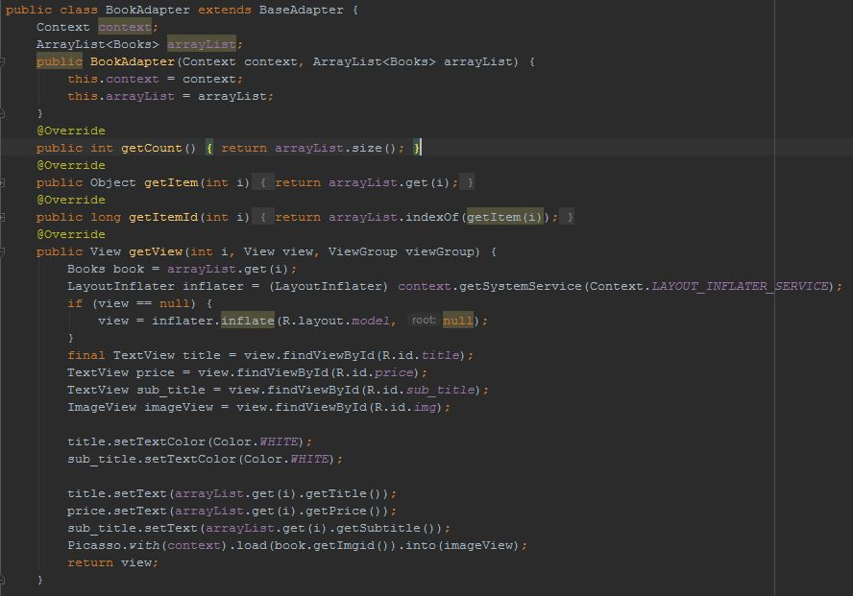

We create a new class and make it extend “BaseAdapter” so it adds Override methods such as “getItem” that return the item at given index,

So, to put items in ListView we override “getView” and inside it we get the first object from the Books arrayList then declare each component of the list we need to pass a value to it then give it the value and return the view, then it’ll create the ListView on the layout and put the items on it.

-ListView item Click:

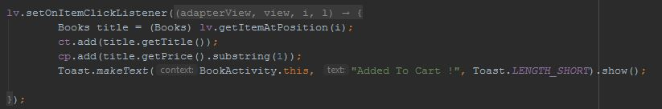

On the BookList Activity when we click on any item it’ll be added to the Cart to confirm the buying process on it.

-On the top of the Activity there’s “Add to Cart” button:

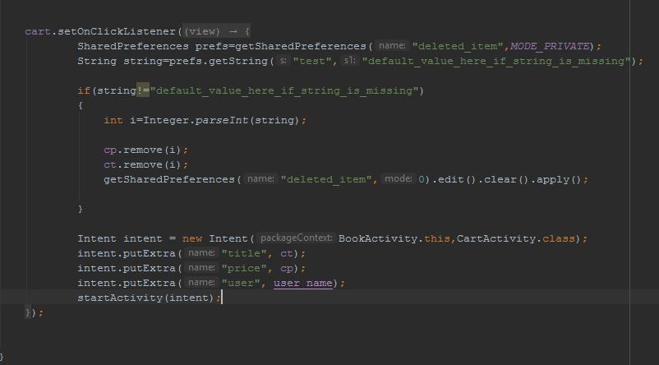

It takes the title and price of the selected book and move it to the cart.

4 – Cart & Confirmation Activity:



In this Activity we have a ListView with a button and EditText.

To make the items appear on the ListView we made a new adapter like the BookAdapter

But it only returns the view with title and price only, and we used the Books class too with the adapter.

-Cart Adapter Code:

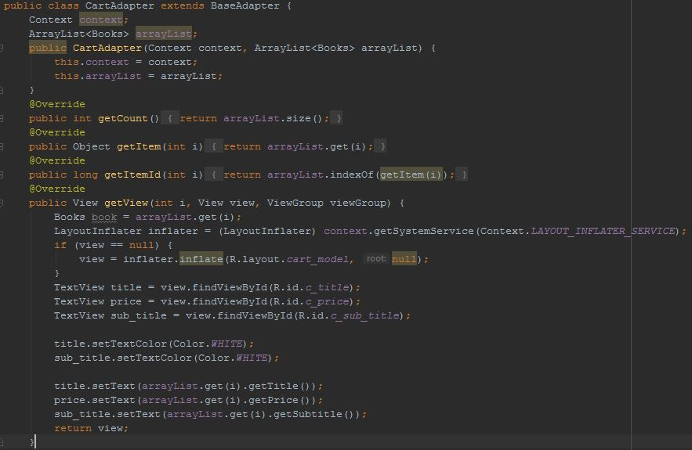

Everything we did in the BookAdapter class we did it here too, but we removed the images and sub-title from it, so it’ll make a view with title and price only.

In this activity we used a method that takes the price of every existed book from the arraylist passed from the previous activity and get its total price and shows it on the top of the activity:

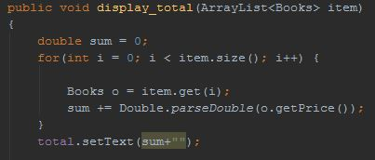

In this activity If the user added a book and before buying he doesn’t want it he can easily click on it to remove it from the cart:

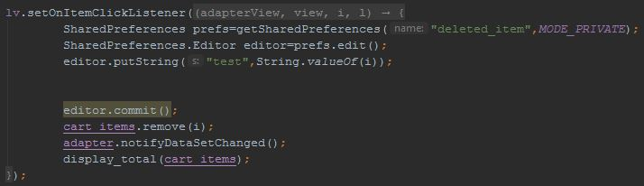

This code removes the selected item from the list and refreshes it.

-CartActivity Confirm Buying Button:

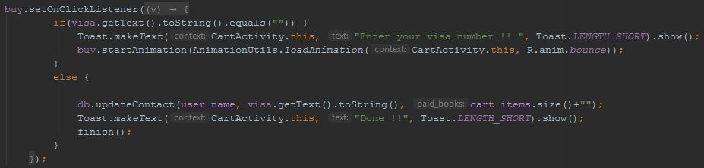

If we press the button with a blank visa EditText it’ll give us a toast with the error, else it’ll take the username of the user, his visa number and the number of books he bought and save it to the database.